17). Demonstrate Infrastructure as a Service (IaaS) by creating a Virtual Machine using a Public Cloud Service Provider (Azure), configure with required memory and CPU.

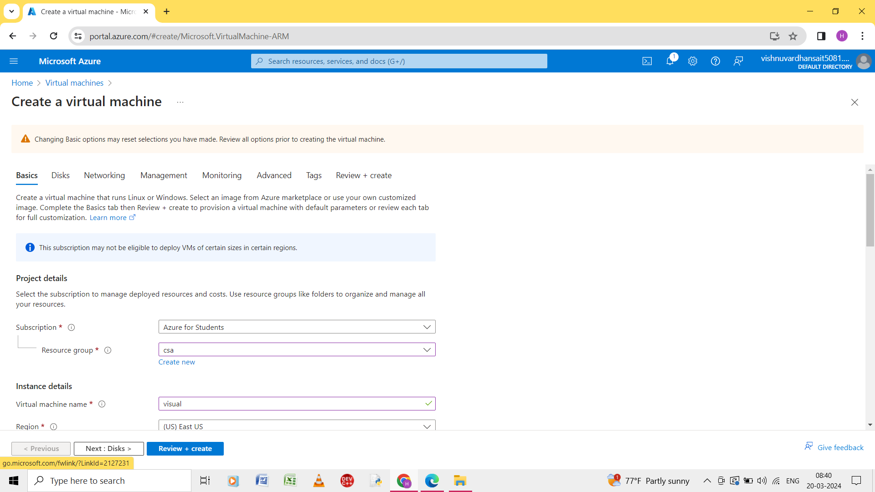

Step 1: create the new virtual machine.

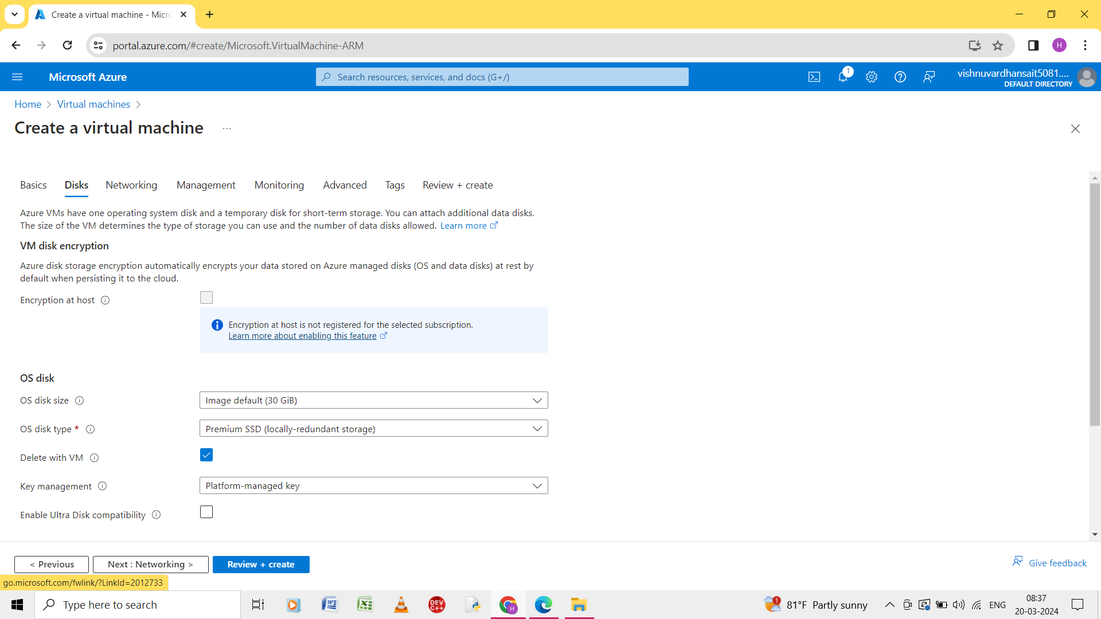

Step 2: give the details of basic and disks.

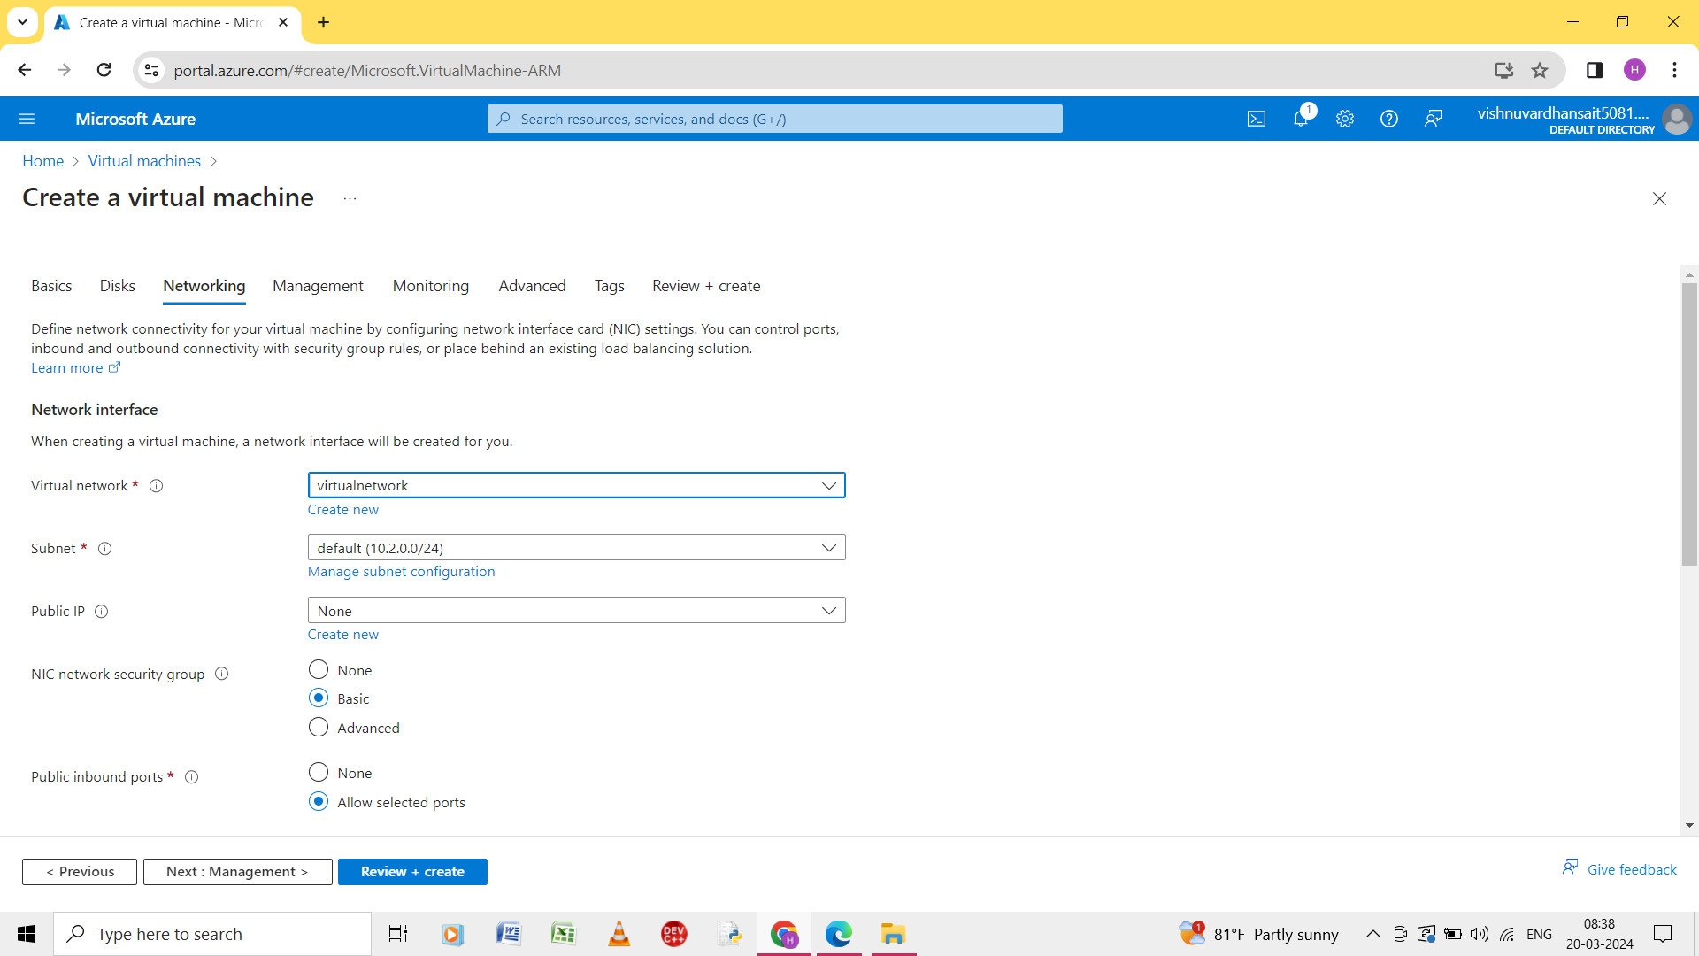

Step 3: enter the name of the virtual machine.

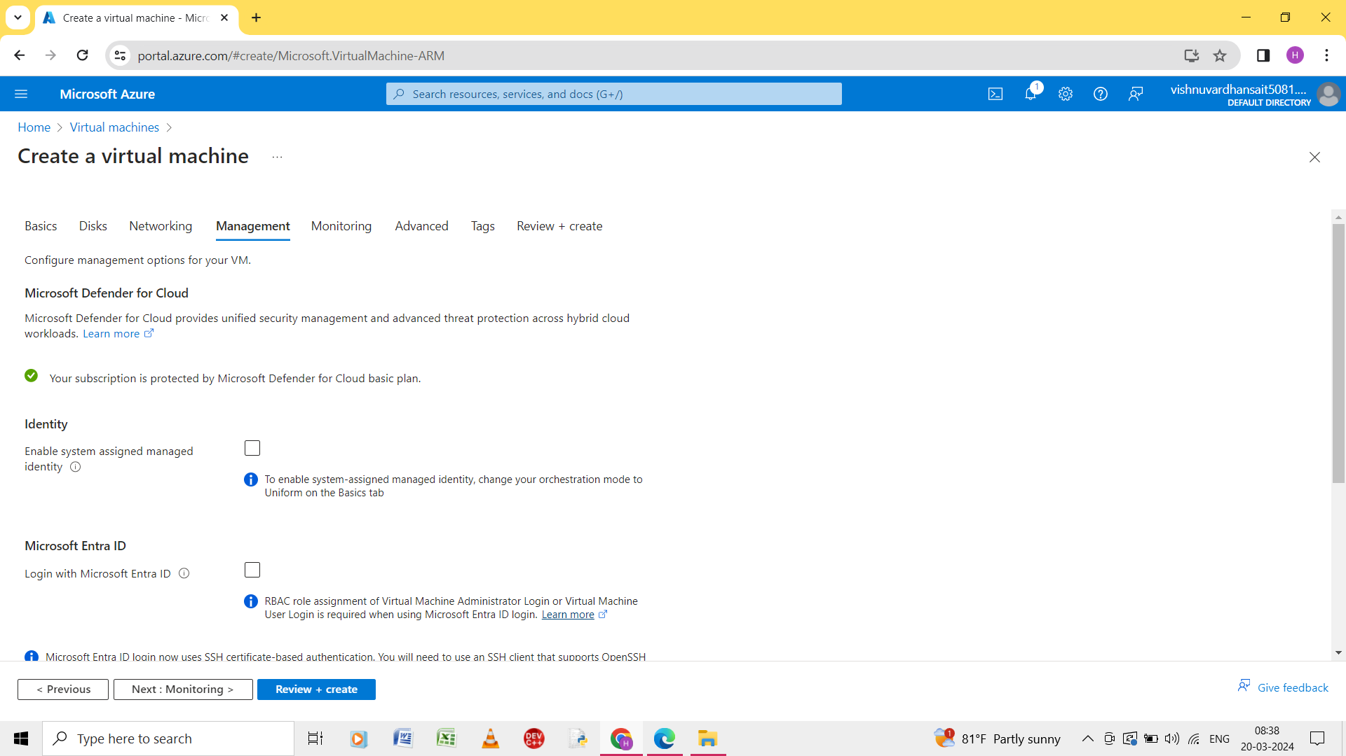

Step 4: give the degtails of the management.

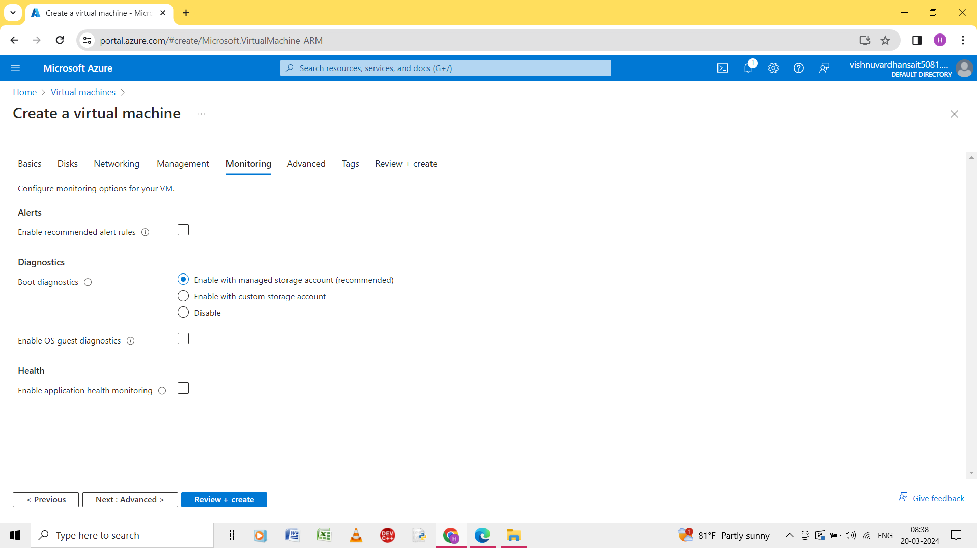

Step 5: enter the details of the monitoring.

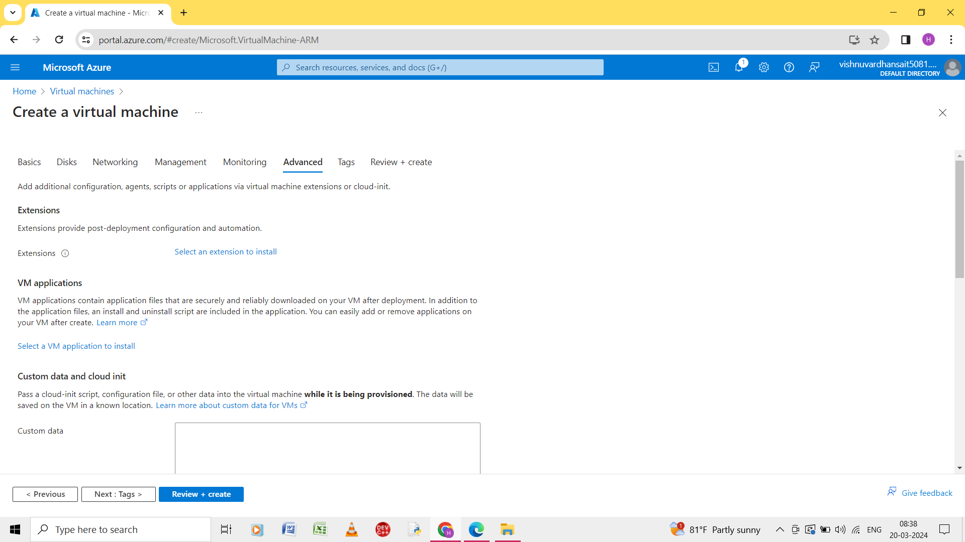

Step 6: enter the details of advanced.

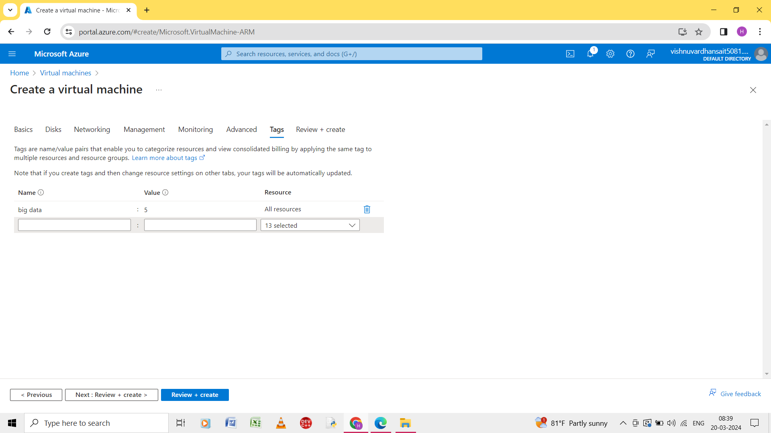

Step 7: enter the details of the tags.

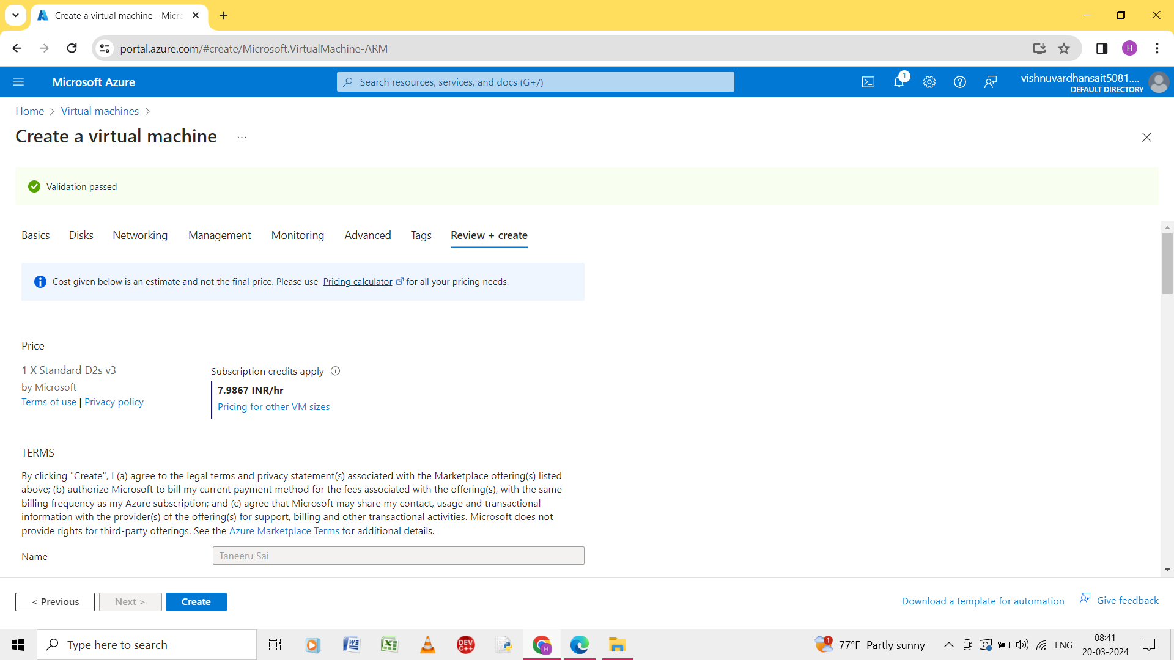

Step 8: the validation is passed is shown.